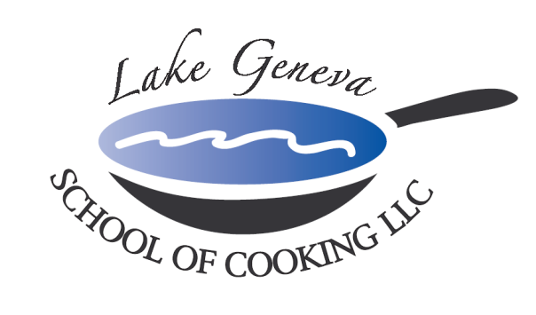

Potato Crusted Salmon Fillet
Duet of Three Mustard Sauce & Chili Pepper Puree

Serves 10
Ingredients:

10 Salmon fillets, 2 oz. each
1 cup fortified oil (1/2 oil & ½ butter)
6 ea. Russet potatoes, peeled
2 egg yolks
¼ cup flour
4 Tbsps Dijon Mustard
Chef John's Signature Seasoning, to taste
3 in. round Ramekins, 5 each
2 cups Three Mustard Sauce
¼ cup Chili Pepper Coulis

Preparation:
- Shred peeled potatoes in cold water, rinse, drain, and dry. In an additional bowl, add potatoes, egg yolks and flour. Toss to incorporate.
- Season salmon with Chef John’s Signature Seasoning.
- Fill lower 1/3 of ramekin with shredded potato, while allowing some potato to come up the sides. Add salmon fillet and ½ Tbsp. of Dijon mustard. Top exposed salmon with additional potato.
- Bring fortified oil to medium-hot temperature.
- Invert salmon and potato ramekin onto spatula. Gently slide into hot fortified oil, cook 3-4 minutes on each side and remove onto sheet pan.
- Finish in 335º oven for 5-6 minutes, making sure potato crust is warm.
- Ladle 2 oz. of Three Mustard Sauce on the center of the plate. Drizzle Chili Pepper Puree around outer edge of mustard sauce and pull through with toothpick in an attractive design.
- Place potato crusted salmon in center of plate.

Three Mustard Sauce

Yields: 3 cups
Ingredients:

3 Tbsps. Dijon mustard
3 Tbsps. honey mustard
3 Tbsps. whole grain mustard
2 Tbsps. white wine
1 Tbsp. white wine vinegar
12 oz. half & half
6 oz. heavy cream
Chef John’s Signature Seasoning, to taste

Preparation:
- Whisk all ingredients together in a saucepan.
- Bring to boiling point and let simmer for 20 minutes.

