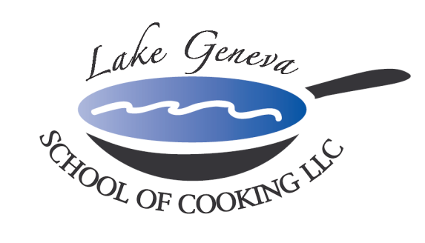
Count Down to 2027 at the
Lake Geneva School of Cooking!

As we ring in 2027 ~ join us for our New Year’s celebration around the world!

Beginning in Sydney on Sunday, December 27th, this
“Hands-On” cooking class travels around the globe in tastes and presentations of:
Rome, Paris & New York (December 28-30).

But the real countdown begins with
Two classes on New Year’s Eve
“Celebrating Lake Geneva-Style”. In addition to a New Year’s toast, guests will enjoy a “Hands-On” cooking class, four-course meal, wine tasting, and a night full of good times, good health and good food.

Countdown to New Year’s 2027 classes each night from 6 pm to 10 pm on:
Sunday, December 27th ~ Monday, December 28th ~
Tuesday, December 29th ~ Wednesday, December 30th

On Thursday, December 31st, we offer two classes:
Session I: 1 pm to 5 pm
Session II: 7 pm to 11pm
(Please feel free to go out and celebrate your midnight
toast at your favorite local establishment.)

New Year’s Eve Celebration
Around the World in Lake Geneva
(A Sampling of Menu Items)

Parmigiano Popovers
Sparkling Wine Reception

Lobster and Shrimp Raviolis
Tomato Basil Reduction

Black Truffle Soup Lyonnaise
Topped with Puff Pastry

Kona Crusted Chateau Briand of Beef
Roasted Shallot & Cabernet Sauvignon Reduction

Chocolate Midnight Truffle Cake
Grand Marnier Truffles

