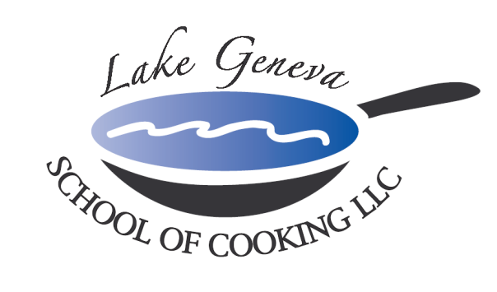

Christmas Candlelight Dinner 2026
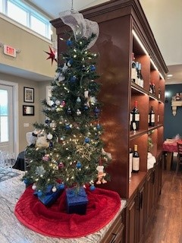
After a day of shopping, enjoy a beautiful Christmas Candlelight Dinner at the Lake Geneva School of Cooking. Allow us to take you on a culinary field trip as we present a dinner menu highlighting classic Holiday Dishes and match each with excellent wine tasting.
Begin the Christmas Candlelight Dinner with a Sparkling Wine Reception with Holiday Popovers, as Chef introduces himself and goes over the Holiday Themed menu. The Lake Geneva School of Cooking team will demonstrate some basic cuts and important safety techniques before getting broken up into teams.
Then let the "hands-on" cooking begin as you slice, dice, chop, laugh, and dance to traditional favorites and new Holiday music; while each team creates a delicious dish from the four-course menu under the guidance of Chef and the Team.
After all the cooking is completed, everyone will resign to the Dining Room, and enjoy a candle lit dining experience you helped create.
Christmas Candlelight Dinner

Sunday, December 6th
Sunday, December 13th
Sunday, December 20th
$150 per person
Classes are held 5:00 pm- 9:00 pm

Sample Candlelight Menu:

Holiday Popovers
Sparkling Wine Reception

Potato Crusted Salmon Fillet
Duet of Three Mustard Sauce and Berry Coulis

Pasta Shells Stuffed With Three Cheeses
Cloe’s Italian Sausage Gravy

Roast Turkey Breast Wellington
River Valley Mushroom Duexelle and Market Vegetables

Chocolate Grand Marnier Tart
Chantilly Cream and Berry Coulis

