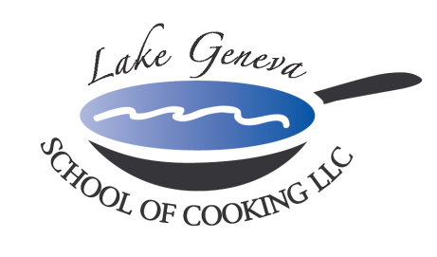

Lake Geneva Lake Life Team Building Event
What goes better then Guys, Girls, Turf & Tails?
Lake Geneva School of Cooking‘s Lake Life Team Building Event!

Spend a day with co-workers enjoying this Up-Scale Steakhouse influenced Turf & Tails menu. Guests will be slicing, dicing, chopping, grilling, dancing, and laughing together preparing recipes from Chef John’s cook book: CHEF JOHN BOGAN RECIPES FROM THE SEASONS OF MY LIFE.
Our Lake Life “Hands-On” Team Building Event creates an environment promoting creativity, communication and cooperation among participants, allowing them to relate to one another in
ways not possible in the office.

Lake Life Team Building Sample Menu includes:

Sparkling Wine and Parmigiano Popover Reception
Spinach Stuffed Mushroom Cap with Black Truffle
Grilled Caesar Salad with Homemade Italian Sausage
USDA Prime Filet Mignon & Sweet Lobster Tail
Grand Marnier Dark Chocolate Mousse

Private Facility Fee includes:
The $400 private facility fee includes a Consultation with Chef John on business meeting agenda, choice of menu options, hands-on cooking class, coaching by your Chef and LGSC staff, Sparkling Wine and Popover Reception, non-alcoholic beverages, a tasting wine provided while cooking and a delicious four-course meal.

Price per participant:
Primary Package is $295 per participant. The Primary Package includes a “Hands-On class coached by your Chef and the LGSC staff, a sparkling wine and Parmigiano Popovers reception, a tasting wine and a delicious four-course meal. All participants will receive a signed copy of CHEF JOHN BOGAN RECIPES FROM THE SEASONS OF MY LIFE cook book

How to Register
For more information on customizing and setting up your Lake Life Team Building Event, please contact Chef/Owner/Author John Bogan. Minimum guest requirements: eight (8) guests on weekdays, 15 guests on Friday and 20 guests on Saturday to reserve your Lake Life Team Building Event.
Payment Policy
Additional costs include: supplemental wine, a sales tax of 5.5% and a service charge of 20%. The Lake Geneva School of Cooking requires a 50% deposit, upon reserving the date for your event. Accepting all major credit cards, the balance must be paid in full on the date of your party. *LGSC prohibits outside alcoholic beverages.

