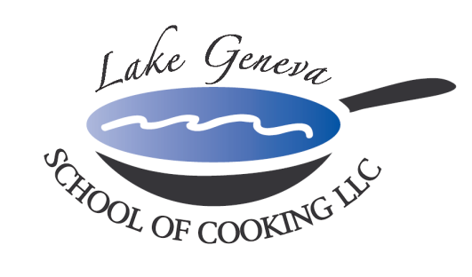

Holiday Social Reception Event
“Social Reception Team Building Events & Good Food brings people together!”

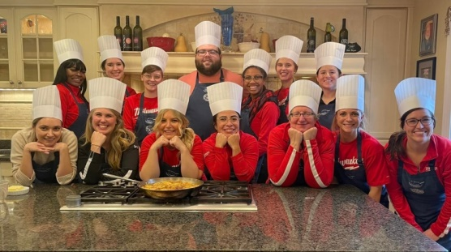
Spend a day with co-workers celebrating the Holidays and head to Lake Geneva School of Cooking for a Customized
Holiday Social Reception Event!

Our “Hands-On” Holiday Social Reception Event creates an environment promoting your company specific needs and goals though communication and cooperation among participants while recreating recipes from CHEF JOHN BOGAN
RECIPES FROM THE SEASONS OF MY LIFE cook book.

A typical Holiday Social Reception Event includes:
- Upon arrival; introduced to your Chef and LGSC staff, toast with a sparkling wine and enjoy Popovers, and discuss the event menu.
- Your group is broken into teams, each receiving a recipe for their assigned menu item, a chef hat and an apron. Your Chef will lead a group lesson in basic techniques in preparation of the event’s dishes, and safety and sanitation. Then the fun begins, as each team begins to prepare assigned menu item under the guidance of your Chef and the LGSC staff.
- Let’s Eat! Once the cooking is complete, the group will join together for the fine dining portion of the event. Each team will set up their Social Reception platter and present their team dish on the buffet.
- Your Chef will assist with wine choices for your events menu.
- Total Event Time: approximately three and a half (3-3 ½ ) hours

Private Facility Fee
The $400 private facility fee includes: a Consultation with Chef John on business meeting agenda, a custom menu, a “Hands-On” cooking class, coaching by your Chef and the LGSC staff, a Sparkling Wine and Popover Reception, non-alcoholic beverages, a tasting wine while cooking and a delicious four-course meal.

Pricing
Primary Package is $120 per participant. The Primary Package includes a “Hands-On” class coached by your Chef and the LGSC staff, a sparkling wine and Parmigiano Popovers reception, a tasting wine and a delicious four-course meal.

Deluxe Package is $160 per participant. The Deluxe Package includes all items in the Primary Package, plus a gift bag with a Lake Geneva School of Cooking apron, Chef John’s Signature Seasoning, and kitchenware.
Cook Book Package is $180 per participant. The Cook Book Package includes all items in the Primary Package, plus a signed copy of CHEF JOHN BOGAN RECIPES FROM THE SEASONS OF MY LIFE cook book and Chef John’s Signature Seasoning.
Participants: Holiday Event Dates: November 28, 2025 through January 31, 2026
The Lake Geneva School of Cooking Holiday Event minimum guest requirements: 10 guests Monday-Thursday afternoons, 12 guests Monday-Thursday evenings, 15 guests on Fridays and Sundays and 25 guests on Saturdays.
Payment Policy
Additional costs include: supplemental wine, a sales tax of 5.5% and a service charge of 25%. The Lake Geneva School of Cooking requires a 50% deposit, upon reserving the date for your event. Accepting all major credit cards, the balance must be paid in full on the date of your party. *LGSC prohibits outside alcoholic beverages.

How to Register
For more information on customizing and setting up your Holiday Event, please contact
Chef/Author/Owner; John Bogan at 262-248-3933.

