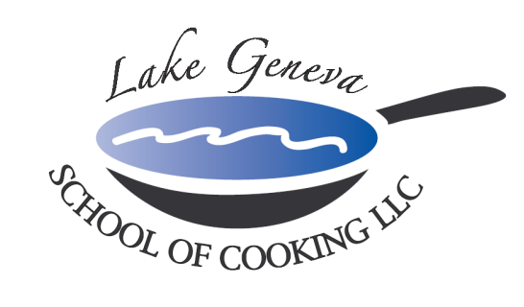

Iron Chef Team Building Competition
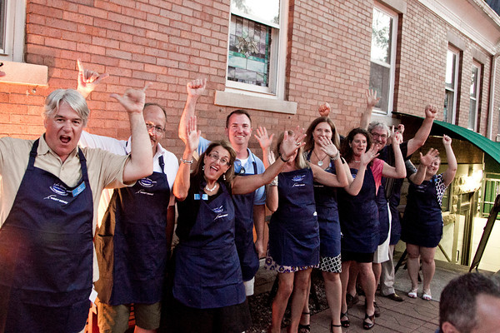
Do you like the thrill of being an Iron Chef?
Do you like to Throw Down in the kitchen?
Challenge your Office Staff, Management Staff, and Team Leaders in this highly successful Iron Chef Competition.

Spend a day with co-workers outside the office enjoying this “Hands-On Cooking Class” while incorporating a Mystery Ingredient into each dish! Recipes are from CHEF JOHN BOGAN RECIPES FROM THE SEASONS OF MY LIFE cook book.
Meeting your specific needs and company agenda, Iron Chef Competition creates an environment that promotes creativity, communication and cooperation among participants, allowing them to relate to one another in ways not possible in the office. Bringing elements of teamwork from the workplace into our kitchen, each team is called upon to use collaboration, commitment, problem solving and leadership.

A typical Iron Chef Experience is as follows:
- Before the event, background information, such as meeting agenda and buzzwords, is obtained so the team-building experience can be customized for your group
- Upon arrival, guests will enjoy a Sparkling Wine and Popover Reception.
- The group is then broken into teams, each receiving a recipe for assigned course, and their Mystery Ingredient.
- Next, group lesson in basic techniques used in the preparation of the dishes, as well as in safety and sanitation.
- Then the fun begins, as each team begins to prepare their course under the guidance of Chef and the staff.
- Teams work together to complete their course and incorporate the Mystery Ingredient
- Teams have 90 minutes to create their course (1 additional plate - for judges)
- Teams will be judged on originality, plate presentation, and taste.
- Also considered by judges; teamwork, problem solving, and creativity.
- The group will then join together for the fine dining portion of the event. Each team will plate their course and help serve their fellow co-workers. In addition, Chef is available in helping teams choose a wine to pair with their course.
- The team with the highest score wins.
- Total Event Time: about four hours

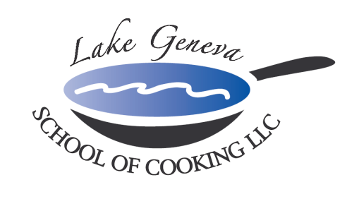

Pricing
Private “Hands-On” Iron Chef Competition:
Private Facility Fee includes:
The $400 private facility fee includes a Consultation with Chef John on business meeting agenda, choice of menu options, hands-on cooking class, coaching by Chef and Staff, Sparkling Wine and Popover Reception, non-alcoholic beverages, a tasting wine while cooking and a delicious four-course meal.

Price per participant:
Primary Package is $125 per participant. The Primary Package includes a hands-on class coached by Chef John and our staff, a sparkling wine and Parmigiano Popovers reception, a tasting wine and a delicious four-course meal.

Deluxe Package is $160 per participant. The Deluxe Package includes all items in the Primary Package, plus a gift bag with a Lake Geneva School of Cooking apron, Chef John’s Signature Seasoning, and kitchenware.
Cook Book Package is $180 per participant. The Cook Book Package includes all items in the Primary Package, plus a signed copy of CHEF JOHN BOGAN RECIPES FROM THE SEASONS OF MY LIFE cook book and Chef John’s Signature Seasoning.
Premier Package is $280 per participant. The Premium Package includes all items in the Deluxe Package, plus a signed copy of CHEF JOHN BOGAN RECIPES FROM THE SEASONS OF MY LIFE cook book, and a Lake Geneva School of Cooking Chef Jacket.
How to Register
For more information on customizing and setting up your Iron Chef Competition, please contact Chef and owner, John Bogan, at 262-248-3933. Minimum of eight guests (Saturday requires 15) to reserve Iron Chef Competition.
Payment Policy
Additional costs include: supplemental wine, a sales tax of 5.5% and a service charge of 20%. The Lake Geneva School of Cooking requires a 50% deposit, upon reserving the date for your event. Accepting all major credit cards, the balance must be paid in full on the date of your party.
*LGSC prohibits outside alcoholic beverages.

