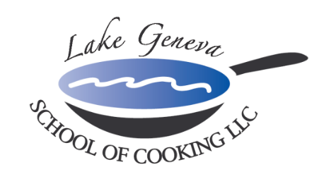

Social Reception Team Building Event
“Social Reception Team Building Events & Good Food brings people together!”
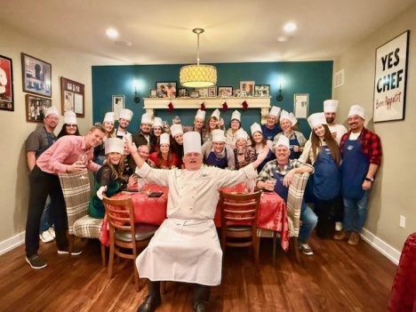
Spend a day with co-workers outside the office and head to Lake Geneva School of Cooking for a Customized
Social Reception Team Building Event!

Our “Hands-On” Social Reception Team Building Events create an environment promoting your company specific needs and goals though communication and cooperation among participants while recreating recipes from CHEF JOHN BOGAN
RECIPES FROM THE SEASONS OF MY LIFE cook book.

A typical Social Reception Team Building Event includes:
- Prior to the event: Chef gathers background information, meeting themes, buzzwords, and menu
- Upon arrival: introduced to your Chef and LGSC staff, toast with a sparkling wine and enjoy Hors d’oevres, and discuss the Team Event menu.
- Menu Prep: Your group is then broken into teams, each team receiving a recipe for their course, assigned a Chef Mate, a chef hat and an apron.
- Lessons: group lesson in basic cooking techniques, preparation of the food, kitchen safety and kitchen sanitation.
- The fun begins; each team begins preparing assigned recipes under the guidance of Chef John and Chef Mates.
- Let’s Eat! The group will then join together for the Fine Dining portion of the event. Each team will elect a representative to present their Social Reception creative dish to the Group.
- The chef is available to help the group choose a dinner wine to pair with each course.
- Total Event Time: approximately three (3-3 1/2) hours

“Hands-On” Social Reception Team Building Event:
Private Facility Fee
The $400 private facility fee includes: a Consultation with Chef John on business meeting agenda, a custom menu, a “Hands-On” cooking class, coaching by your Chef and the LGSC staff, a Sparkling Wine and Popover Reception, non-alcoholic beverages, a tasting wine while cooking and a delicious four-course meal.

Pricing
Primary Package is $120 per participant. The Primary Package includes a “Hands-On” class coached by your Chef and the LGSC staff, a sparkling wine and Parmigiano Popovers reception, a tasting wine and a delicious four-course meal.

Deluxe Package is $160 per participant. The Deluxe Package includes all items in the Primary Package, plus a gift bag with a Lake Geneva School of Cooking apron, Chef John’s Signature Seasoning, and kitchenware.
Cook Book Package is $180 per participant. The Cook Book Package includes all items in the Primary Package, plus a signed copy of CHEF JOHN BOGAN RECIPES FROM THE SEASONS OF MY LIFE cook book and Chef John’s Signature Seasoning.
Participants
The Lake Geneva School of Cooking Event minimum guest requirements: 10 guests Monday-Thursday afternoons, 12 guests Monday-Thursday evenings, 15 guests on Fridays and Sundays and 25 guests on Saturdays.

Payment Policy
Additional costs include: supplemental wine, a sales tax of 5.5% and a service charge of 25%. To reserve your event, the Lake Geneva School of Cooking requires a 50% deposit LGSC accepts all major credit cards (3% fee) or ACH transfers, the balance must be paid in full upon completing your event. *LGSC prohibits outside alcoholic beverages.

