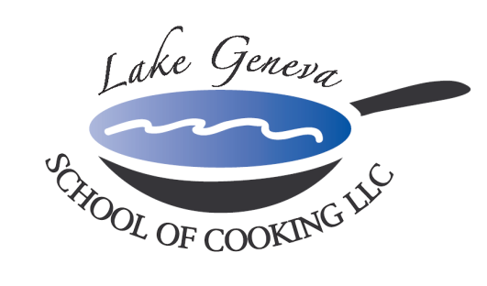

Corporate Team Building Event
“Corporate Team Building Culinary Events & Good Food brings people together!”

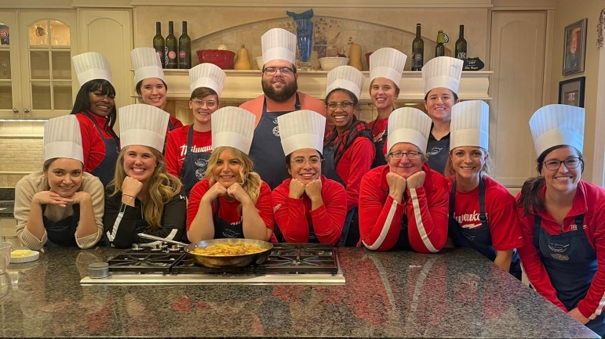
Spend a day with co-workers outside the office and head to Lake Geneva School of Cooking
for a Customized
Corporate Team Building Culinary Event!

Our “Hands-On” Corporate Team Building Culinary Events create an environment promoting your company specific needs and goals though communication and cooperation among participants while recreating recipes from CHEF JOHN BOGAN RECIPES FROM THE SEASONS OF MY LIFE cook book.

In addition, we successfully transfer the essential elements of teamwork from the workplace into our kitchen; each team is called upon to use collaboration, commitment, goal orientation and leadership.

A typical Corporate Team Building Culinary Event includes:

- Before the event, background information, such as meeting themes and buzzwords, is obtained so the team-building experience can be customized for your group
- Upon arrival, you will be introduced to your Chef and our LGSC staff.
- To start off the event, your group will toast with a sparkling wine and enjoy Parmigiano popovers, while discussing the night’s menu.
- The group is then broken into teams, each receiving a recipe for their assigned course, a chef hat and an apron.
- Your Chef will lead a group lesson in basic techniques used in the preparation of the event’s dishes, as well as in safety and sanitation.
- Then the fun begins, as each team begins to prepare their course under the guidance of your Chef and the LGSC staff.
- Let’s Eat! Once the cooking is complete, the group will then join together for the fine dining portion of the event. Each team will plate their course and help serve their fellow co-workers.
- Your Chef is available in helping teams choose a wine to pair with their course.
- Total Event Time: approximately four (4) hours

Private “Hands-On” Corporate Team Building Culinary Event Pricing:
Private Facility Fee includes:
The $400 private facility fee includes a Consultation with Chef John on business meeting agenda, choice of menu options, hands-on cooking class, coaching by your Chef and the LGSC staff, Sparkling Wine and Popover Reception, non-alcoholic beverages, a tasting wine while cooking and a delicious four-course meal.

Pricing:
Primary Package is $120 per participant. The Primary Package includes a “Hands-On” class coached by your Chef and the LGSC staff, a sparkling wine and Parmigiano Popovers reception, a tasting wine and a delicious four-course meal.

Deluxe Package is $160 per participant. The Deluxe Package includes all items in the Primary Package, plus a gift bag with a Lake Geneva School of Cooking apron, Chef John’s Signature Seasoning, and kitchenware.
Cook Book Package is $180 per participant. The Cook Book Package includes all items in the Primary Package, plus a signed copy of CHEF JOHN BOGAN RECIPES FROM THE SEASONS OF MY LIFE cook book and Chef John’s Signature Seasoning.
Premier Package is $275 per participant. The Premier Package includes all items in the Primary Package, plus a signed copy of CHEF JOHN BOGAN RECIPES FROM THE SEASONS OF MY LIFE cook book, Chef John’s Signature Seasoning and a Lake Geneva School of Cooking Chef Jacket.

How to Register
For more information on customizing and setting up your Corporate Team Building event, please contact Chef/Owner/Author John Bogan, at 262-248-3933. Minimum guest requirements: eight (8) guests on weekdays, 15 guests on Friday and 20 guests on Saturday to reserve your Corporate Team Building Culinary Event.
Payment Policy
Additional costs include: supplemental wine, a sales tax of 5.5% and a service charge of 20%. The Lake Geneva School of Cooking requires a 50% deposit, upon reserving the date for your event. Accepting all major credit cards, the balance must be paid in full on the date of your party.
*LGSC prohibits outside alcoholic beverages.

Recent comments include:
“We wanted to take a moment to thank you for the outstanding job you and your staff did for our client, West Bend, during the President’s Round Table program we recently held in Lake Geneva. We always strive to have at least one off the chart element in each program, and thanks to you, we were able to have TWO on this one.”
-Leslie and Michelle, Viktor Incentives & Meetings, Traverse City MI

“The group had an OUTSTANDING experience at the Lake Geneva School of Cooking. I truly believe we hosted one of the best meetings for this group, and you played a very large role in that success! Your staff was absolutely terrific to work with, and we thank each of you for all your hard work and such a delicious meal.”
-Beth, Taylor Company and McDonald’s, Rockton IL

“I was a little nervous about how our group would take to this type of group function, but one and all enjoyed it tremendously and I am still hearing great comments.”
-Beverly, Mizkan America, Mt. Prospect IL

“It was virtually unanimous that this was the best team building exercise that Elobau North America has participated in to date!”
-Chris, Elobau North America, Waukegan IL

