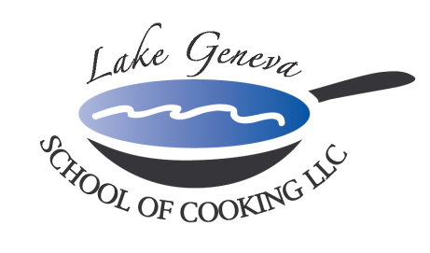

Prime Time Team Building Competition
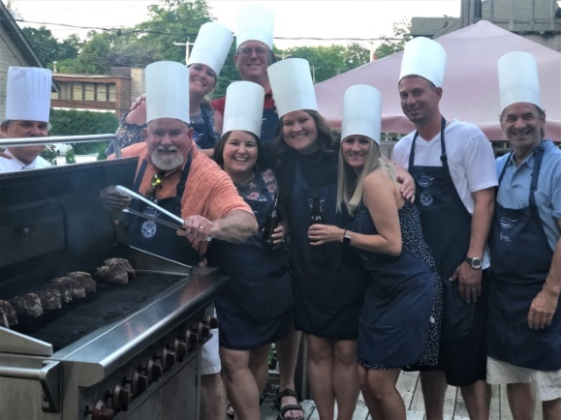
What goes better then Guys, Girls & Grilling?
Lake Geneva School of Cooking ‘s Prime Time Corporate Team Building Event!

Spend a day with co-workers outside the office enjoying this Up-scale Steakhouse influenced menu. Guests will be grilling and caramelizing Crème Brulee with recipes from CHEF JOHN BOGAN RECIPES FROM THE SEASONS OF MY LIFE cook book.

Prime Time creates an environment that promotes creativity, communication and cooperation among participants, allowing them to relate to one another in ways not possible in the office.

Prime Time Team Building Sample Menu includes:
Sparkling Wine and Parmigiano Popover Reception
Classic French Onion Soup
Wisconsin Wedge Salad
USDA Prime Bone-In Filet Mignon
Vanilla Bean Crème Brulee

Private Facility Fee includes:
The $400 private facility fee includes a Consultation with Chef John on business meeting agenda, choice of menu options, hands-on cooking class, coaching by Chef and Staff, Sparkling Wine and Popover Reception, non-alcoholic beverages, a tasting wine while cooking and a delicious four-course meal.

Price per participant:
Primary Package is $125 per participant. The Primary Package includes a hands-on class coached by Chef John and our staff, a sparkling wine and Parmigiano Popovers reception, a tasting wine and a delicious four-course meal.

Deluxe Package is $160 per participant. The Deluxe Package includes all items in the Primary Package, plus a gift bag with a Lake Geneva School of Cooking apron, Chef John’s Signature Seasoning, and kitchenware.
Cook Book Package is $180 per participant. The Cook Book Package includes all items in the Primary Package, plus a signed copy of CHEF JOHN BOGAN RECIPES FROM THE SEASONS OF MY LIFE cook book and Chef John’s Signature Seasoning.
Premier Package is $280 per participant. The Premium Package includes all items in the Deluxe Package, plus a signed copy of CHEF JOHN BOGAN RECIPES FROM THE SEASONS OF MY LIFE cook book, and a Lake Geneva School of Cooking Chef Jacket.
How to Register
For more information on customizing and setting up your Prime Time Competition, please contact Chef and owner, John Bogan, at 262-248-3933. Minimum of eight guests (Saturday requires 15) to reserve your event.
Payment Policy
Additional costs include: supplemental wine, a sales tax of 5.5% and a service charge of 20%. The Lake Geneva School of Cooking requires a 50% deposit, upon reserving the date for your event. Accepting all major credit cards, the balance must be paid in full on the date of your party.
*LGSC prohibits outside alcoholic beverages.

