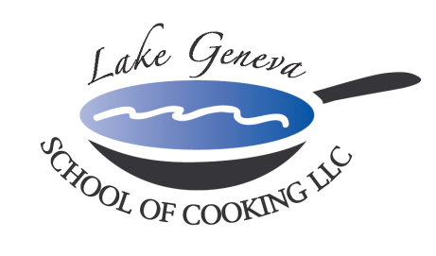

Prime Time Team Building Event
What goes better then Guys, Girls & Grilling?
Lake Geneva School of Cooking‘s Prime Time Team Building Event!

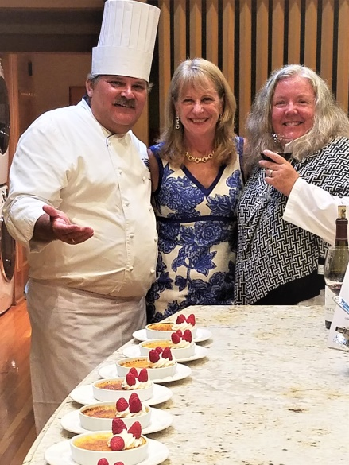
Spend a day with co-workers enjoying this Up-Scale Steakhouse influenced menu. Guests will be slicing, dicing, chopping, grilling, dancing, and laughing and even caramelizing Crème Brulee on fire with recipes
From CHEF JOHN BOGAN RECIPES FROM THE SEASONS OF MY LIFE cook book.

Prime Time creates an environment that promotes creativity, communication and cooperation among participants, allowing them to relate to one another in ways not possible in the office.

Prime Time Team Building Sample Menu includes:
Sparkling Wine and Parmigiano Popover Reception
Classic French Onion Soup
Wisconsin Wedge Salad
USDA Prime Bone-In Filet Mignon
Vanilla Bean Crème Brulee

Private Facility Fee includes:
The $400 private facility fee includes a Consultation with Chef John on business meeting agenda, choice of menu options, hands-on cooking class, coaching by your Chef and LGSC staff, Sparkling Wine and Popover Reception, non-alcoholic beverages, a tasting wine while cooking and a delicious four-course meal.

Price per participant:
Primary Package is $175 per participant. The Primary Package includes a “Hands-On class coached by your Chef and the LGSC staff, a sparkling wine and Parmigiano Popovers reception, a tasting wine and a delicious four-course meal.

Deluxe Package is $200 per participant. The Deluxe Package includes all items in the Primary Package, plus a gift bag with a Lake Geneva School of Cooking apron, Chef John’s Signature Seasoning, and kitchenware.
Cook Book Package is $225 per participant. The Cook Book Package includes all items in the Primary Package, plus a signed copy of CHEF JOHN BOGAN RECIPES FROM THE SEASONS OF MY LIFE cook book and Chef John’s Signature Seasoning.
Premier Package is $325 per participant. The Premier Package includes all items in the Primary Package, plus a signed copy of CHEF JOHN BOGAN RECIPES FROM THE SEASONS OF MY LIFE cook book, and a Lake Geneva School of Cooking Chef Jacket.

Participants
The Lake Geneva School of Cooking Event minimum guest requirements: 10 guests Monday-Thursday afternoons, 12 guests Monday-Thursday evenings, 15 guests on Fridays and Sundays and 25 guests on Saturdays.

Payment Policy
Additional costs include: supplemental wine, a sales tax of 5.5% and a service charge of 25%. The Lake Geneva School of Cooking requires a 50% deposit, upon reserving the date for your event. Accepting all major credit cards, the balance must be paid in full on the date of your party. *LGSC prohibits outside alcoholic beverages.

How to Register
For more information on customizing and setting up your Prime Time Team Building, please contact Chef/Owner/Author John Bogan.

