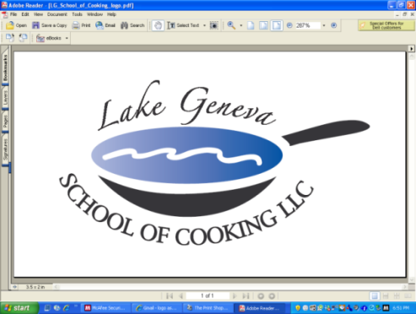

Private Party Celebrations
Private Parties are Our Specialty!
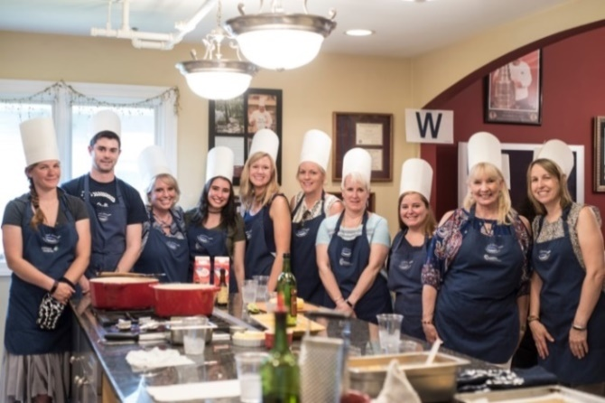

Upon arrival to the Lake Geneva School of Cooking, our staff will greet your Private Party and provide you with a toast of sparkling wine and Parmigiano Popovers.

The Chef will introduce his Team, the menu and provide a brief lesson in the basic techniques used in the preparation of each course, as well as safety and sanitation.

The Chef will divide the Private Menu into teams; each team will be responsible for creating their own segment of the meal with recipes from CHEF JOHN BOGAN RECIPES FROM THE SEASONS OF MY LIFE cook book.

Your Chef and the LGSC staff will float between participants to assist, offer tips and suggestions, and address questions or concerns to make sure that every dish is a success! Once the meal preparation is completed, guests will have the opportunity to sit down and enjoy the Fine Dining portion of your Private Party Celebration. Essentially, you will "break bread" together and enjoy a gourmet meal that was created by the entire group.

Private “Hands-on” Private Party Celebration:
Private Facility Fee includes:
The $400 private facility fee includes: a Consultation with Chef John on business meeting agenda, a choice of menu options, a “Hands-On” cooking class, coaching by your Chef and the LGSC staff, a Sparkling Wine and Popover Reception, non-alcoholic beverages, a tasting wine while cooking and a delicious four-course meal.

Pricing:
Primary Package is $120 per participant. The Primary Package includes a “Hands-On” class coached by your Chef and the LGSC staff, a sparkling wine and Parmigiano Popovers reception, a tasting wine and a delicious four-course meal.

Deluxe Package is $160 per participant. The Deluxe Package includes all items in the Primary Package, plus a gift bag with a Lake Geneva School of Cooking apron, Chef John’s Signature Seasoning, and kitchenware.
Cook Book Package is $180 per participant. The Cook Book Package includes all items in the Primary Package, plus a signed copy of CHEF JOHN BOGAN RECIPES FROM THE SEASONS OF MY LIFE cook book and Chef John’s Signature Seasoning.
Premier Package is $275 per participant. The Premier Package includes all items in the Primary Package, plus a signed copy of CHEF JOHN BOGAN RECIPES FROM THE SEASONS OF MY LIFE cook book, Chef John’s Signature Seasoning and a Lake Geneva School of Cooking Chef Jacket.

Participants
The Lake Geneva School of Cooking Event minimum guest requirements: 10 guests Monday-Thursday afternoons, 12 guests Monday-Thursday evenings, 15 guests on Fridays and Sundays and 25 guests on Saturdays.

Payment Policy
Additional costs include: supplemental wine, a sales tax of 5.5% and a service charge of 25%. The Lake Geneva School of Cooking requires a 50% deposit, upon reserving the date for your event. Accepting all major credit cards, the balance must be paid in full on the date of your party. *LGSC prohibits outside alcoholic beverages.

How to Register
For more information on customizing and setting up your Private Party, please contact Chef /Owner/Author
John Bogan, at 262-248-3933.

