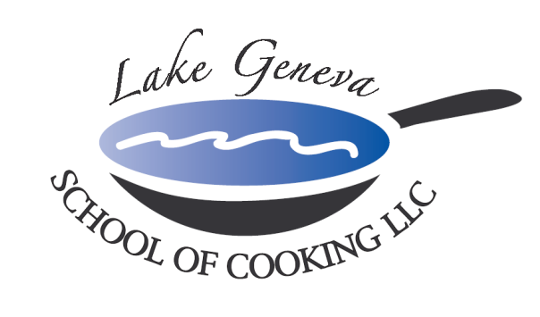

“Tis’ the Season” for Holiday Team Building
and Holiday Private Parties!

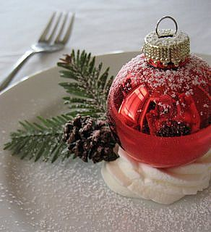
Food always brings people together, so spend an evening with co-workers outside the office and enjoy holiday cooking. With the assistance of our chefs, guests will work together to prepare a delicious, gourmet meal with recipes from CHEF JOHN BOGAN RECIPES FROM THE SEASONS OF MY LIFE cook book, which could be duplicated at your own Holiday party.

As we get into the Holiday spirit, guests will listen to their favorite Christmas carols while enjoying Holiday Popovers. Even better, to spice things up, Chef John will provide guests with a toast of sparkling wine, the perfect chance to wish everyone a happy and healthy new year in this three to four hour event.

To ensure the night is warm and merry, once the meal preparation is complete, guests can relax and mingle among themselves over a beautiful, candlelit dinner they personally prepared.

How to Register
For more information on customizing and setting up your holiday office party, please contact Chef/Author/Owner, John Bogan, at 262-248-3933.
Participants (effective Thanksgiving 2022 through January 7, 2023)
The Lake Geneva School of Cooking requires (minimum 10, Friday-15, Saturday-20) participants for a private Holiday party.
Private Facility Fee
The $400 private facility fee includes: a Consultation with Chef John on business meeting agenda, a choice of menu options, a “Hands-On” cooking class, coaching by your Chef and the LGSC staff, a Sparkling Wine and Popover Reception, non-alcoholic beverages, a tasting wine while cooking and a delicious four-course meal.

Pricing:
Primary Package is $120 per participant. The Primary Package includes a “Hands-On” class coached by your Chef and the LGSC staff, a sparkling wine and Parmigiano Popovers reception, a tasting wine and a delicious four-course meal.

Deluxe Package is $160 per participant. The Deluxe Package includes all items in the Primary Package, plus a gift bag with a Lake Geneva School of Cooking apron, Chef John’s Signature Seasoning, and kitchenware.
Cook Book Package is $180 per participant. The Cook Book Package includes all items in the Primary Package, plus a signed copy of CHEF JOHN BOGAN RECIPES FROM THE SEASONS OF MY LIFE cook book and Chef John’s Signature Seasoning.
Premier Package is $275 per participant. The Premier Package includes all items in the Primary Package, plus a signed copy of CHEF JOHN BOGAN RECIPES FROM THE SEASONS OF MY LIFE cook book, Chef John’s Signature Seasoning and a Lake Geneva School of Cooking Chef Jacket.

Payment Policy
Additional costs include: supplemental wine, a sales tax of 5.5% and a service charge of 20%. The Lake Geneva School of Cooking requires a 50% deposit, upon reserving the date for your event. Accepting all major credit cards, the balance must be paid in full on the date of your party.
*LGSC prohibits outside alcoholic beverages.

