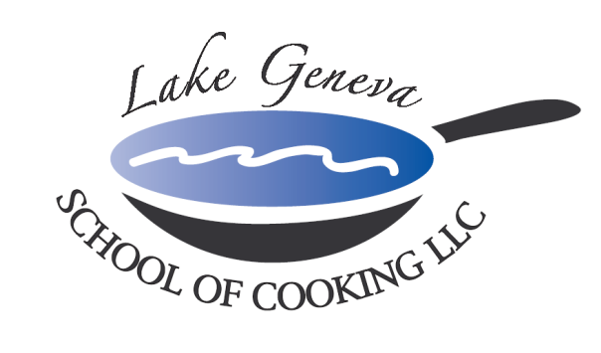

“Tis’ the Season” for Holiday Team Building
and Private Parties!

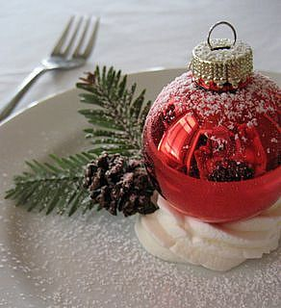
Food always brings people together, so spend an evening with co-workers outside the office and enjoy holiday cooking. With the assistance of our chefs, guests will work together to prepare a delicious, gourmet meal with recipes from CHEF JOHN BOGAN RECIPES FROM THE SEASONS OF MY LIFE cook book, which could be duplicated at your own Holiday party.

As we get into the Holiday spirit, guests will listen to their favorite Christmas carols while enjoying Holiday Popovers. Even better, to spice things up, Chef John will provide guests with a toast of sparkling wine, the perfect chance to wish everyone a happy and healthy new year in this three to four hour event.

To ensure the night is warm and merry, once the meal preparation is complete, guests can relax and mingle among themselves over a beautiful, candlelit dinner they personally prepared.
How to Register
For more information on customizing and setting up your holiday office party, please contact Chef and owner, John Bogan, at 262-248-3933.
Participants
The Lake Geneva School of Cooking requires a minimum of ten (10) (Saturday - minimum 15) participants for a private Holiday party.
Private Facility Fee
For your Holiday Team Building, we will be waiving the $400 Private Facility Fee on weeknights, Monday-Thursday from Monday, November 30th – Thursday, December 17th. With this offer, we would like to thank all of our past holiday guests and welcome new guests to come.

Pricing
Primary Package is $90 per participant. The Primary Package includes a hands-on class coached by Chef John and our staff, a sparkling wine and Holiday Popovers reception, a tasting wine and a delicious four-course meal.

Deluxe Package is $125 per participant. The Deluxe Package includes all items in the Primary Package, plus a gift bag with a Lake Geneva School of Cooking apron, Chef John’s Signature Seasoning, and assorted kitchenware.
Cook Book Package is $150 per participant. The Cook Book Package includes all items in the Primary Package, plus a signed copy of CHEF JOHN BOGAN RECIPES FROM THE SEASONS OF MY LIFE cook book and Chef John’s Signature Seasoning.
Premier Package is $250 per participant. The Premium Package includes all items in the Deluxe Package, plus a signed copy of CHEF JOHN BOGAN RECIPES FROM THE SEASONS OF MY LIFE cook book, and a Lake Geneva School of Cooking Chef Jacket.

Payment Policy
Additional costs include: supplemental wine, a sales tax of 5.5% and a service charge of 20%. The Lake Geneva School of Cooking requires a 50% deposit, upon reserving the date for your event. Accepting all major credit cards, the balance must be paid in full on the date of your party.
*LGSC prohibits outside alcoholic beverages.

